

**DATA COMMUNICATION AND NETWORK LAB**

**TERM PROJECT**

**BS(CS) 4-C**

**Team Members:**

**Name:** Warisha binte Nabil **Enrolment No:** 01-134222-184

**Name:** Faiza Zia **Enrolment No:** 01-134222-044

**Department of Computer Science**

BAHRIA UNIVERSITY, ISLAMABAD

**PROJECT REPORT  
MULTI-BRANCH NETWORK DESIGN**

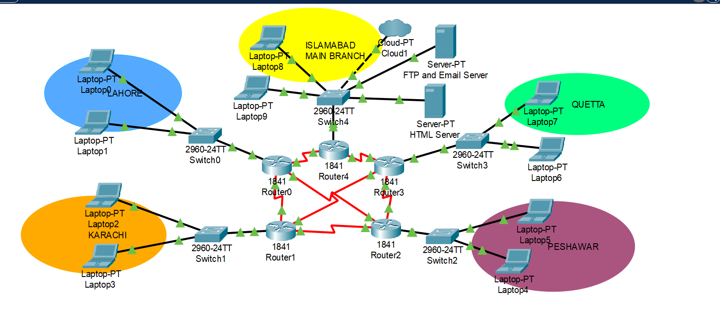

1. **ABSTRACT**

We have designed and implemented a multi-branch network topology intended for a hypothetical organization with branches in multiple cities. The design leverages various network devices including routers, switches, and servers to establish reliable and efficient inter-branch communication. The network is structured to support various services including FTP, email, and HTML services. The evaluation of this design focuses on its robustness, scalability, and efficiency in handling inter-branch communications and services.

1. **INTRODUCTION**

Modern organizations often require robust network infrastructures to ensure seamless communication and service delivery across different branches. This project presents a network design for an organization with branches in Islamabad, Lahore, Karachi, Quetta, and Peshawar. The primary objectives of this design are to ensure high availability, security, and efficient management of network resources.

1. **NETWORK DESIGN**
   1. **OVERVIEW**

The network topology is a hybrid design incorporating both star and mesh elements. The main branch, located in Islamabad, serves as the central hub connecting to all other branches (Lahore, Karachi, Quetta, and Peshawar). This centralized approach simplifies management and enhances security control. The design includes the following key components:

* **Routers:**1841 routers (Router0, Router1, Router2, Router3, Router4)
* **Switches:** 2960-24TT switches
* **End Devices:** Laptops at each branch
* **Servers:** FTP and Email server, HTML server
* **Cloud:** Cloud PT for Internet connectivity
  1. **DETAILED DESCRIPTION**

1. **Main Branch (Islamabad)**
   * **Devices:** Laptops (Laptop8, Laptop9), Switch (Switch4), FTP and Email Server, HTML Server
   * **Connectivity:** The switch connects to Router4 which interconnects with other branch routers (Router0, Router1, Router2, Router3).
2. **Branch Offices**
   * **Lahore:** Laptops (Laptop0, Laptop1), Switch (Switch0), connected to Router0.
   * **Karachi:** Laptops (Laptop2, Laptop3), Switch (Switch1), connected to Router1.
   * **Quetta:** Laptops (Laptop6, Laptop7), Switch (Switch3), connected to Router3.
   * **Peshawar:** Laptops (Laptop4, Laptop5), Switch (Switch2), connected to Router2.
3. **Router Interconnections**
   * The routers are interconnected in a mesh-like structure to ensure multiple paths for data transmission, enhancing redundancy and reliability. This setup allows for efficient routing and failover mechanisms.
4. **Server Configuration**
   * The FTP and Email Server, and HTML Server are centralized in the main branch (Islamabad), accessible by all branches for consistent service delivery.
   1. **NETWORK SERVICES**

* **FTP and Email Services:** Hosted on a dedicated server in Islamabad, accessible by all branches to facilitate file transfers and email communications.
* **HTML Services:** Also hosted in Islamabad to ensure all branches have access to internal web resources.

1. **EVALUATION**

The network design's evaluation focuses on its ability to handle the organization's communication needs, scalability for future growth, and the robustness of its security measures. The mesh-like router interconnection provides high redundancy, ensuring network reliability even if one or more links fail. The centralized server approach simplifies management and ensures consistent service delivery across branches.

* 1. **STRENGTHS**
* **Redundancy:** Multiple interconnections between routers provide alternative paths for data, ensuring network uptime.
* **Centralized Management:** Simplifies administration and security policy enforcement.
* **Scalability:** The design can easily accommodate additional branches or devices.
  1. **WEAKNESSES**
* **Single Point of Failure:** The centralized server approach means that server downtime in Islamabad could impact all branches.
* **Complexity:** The mesh interconnection of routers can be complex to manage and troubleshoot.

1. **CONCLUSIONS**

The proposed network design meets the organizational requirements for robust, secure, and efficient communication across multiple branches. While the centralized server model simplifies management, it is crucial to implement additional measures to mitigate potential single points of failure. Overall, the design is scalable and adaptable, ensuring long-term viability for the organization's network infrastructure.

1. **REFERENCES**

* [Cisco Systems, Inc. (n.d.). Cisco Catalyst 2960 Series Switches. Retrieved from Cisco Catalyst 2960 Series Switches](https://www.cisco.com/c/en/us/support/switches/catalyst-2960-series-switches/series.html)